Create a dockerfile, docker-compose file which when executed must display your basic details in the website.
Creating a docker file in ec2 machine. – Create a directory for our dockerfile
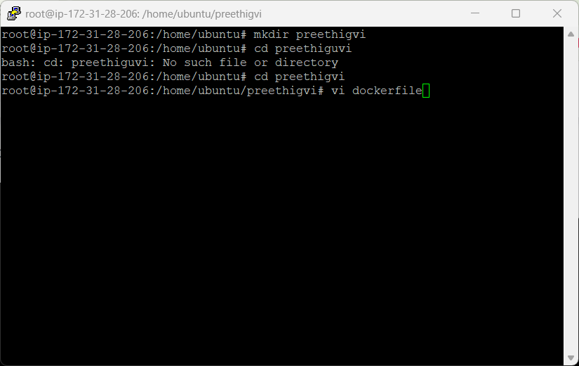

Install packages required to be installed in the docker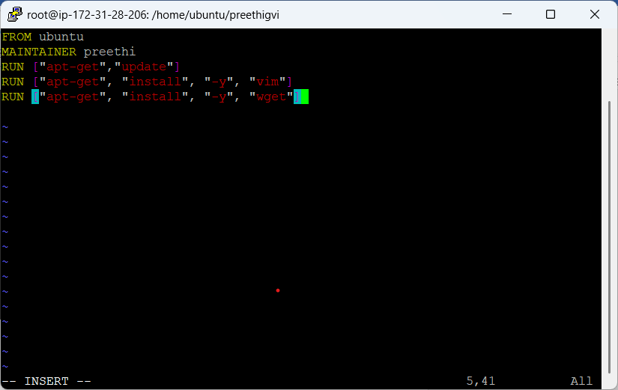
Build the docker file, to get the image out of it
docker build -t preethiimg . preethiimg is image name, . is to mention current directory itself
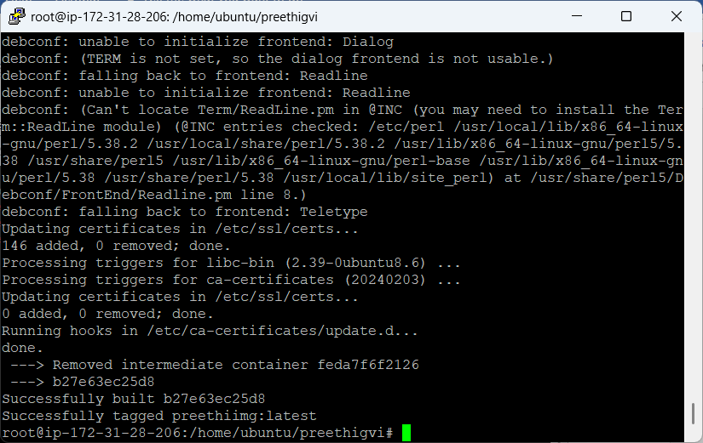

Docker image built can be seen in docker image list
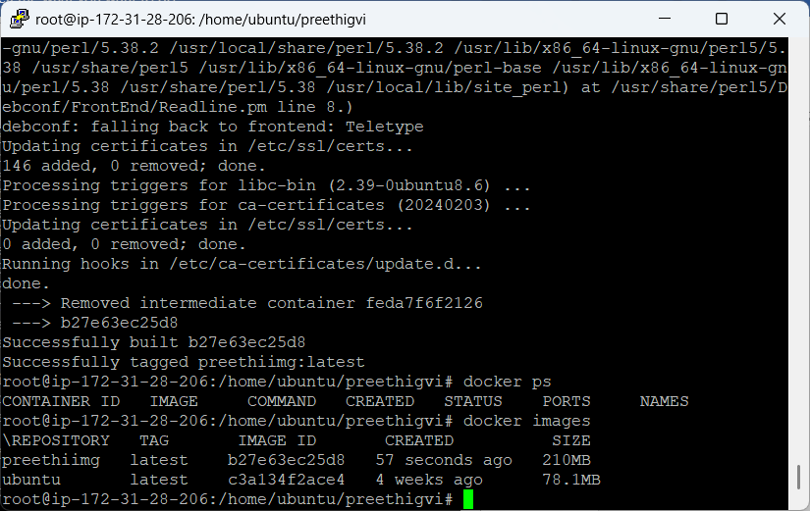
Run the container using the image created
docker run -itd --name vimcont preethiimg
vimcont - name of container
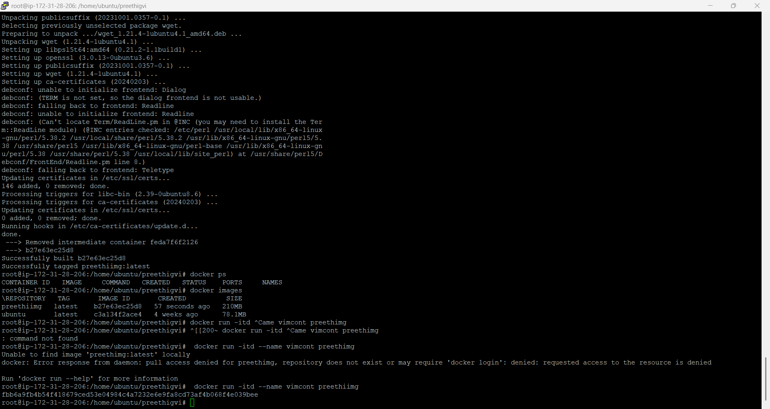

To check if package is available inside, login to container and validate
docker exec -it fbb6a9fb4b54 /bin/bash
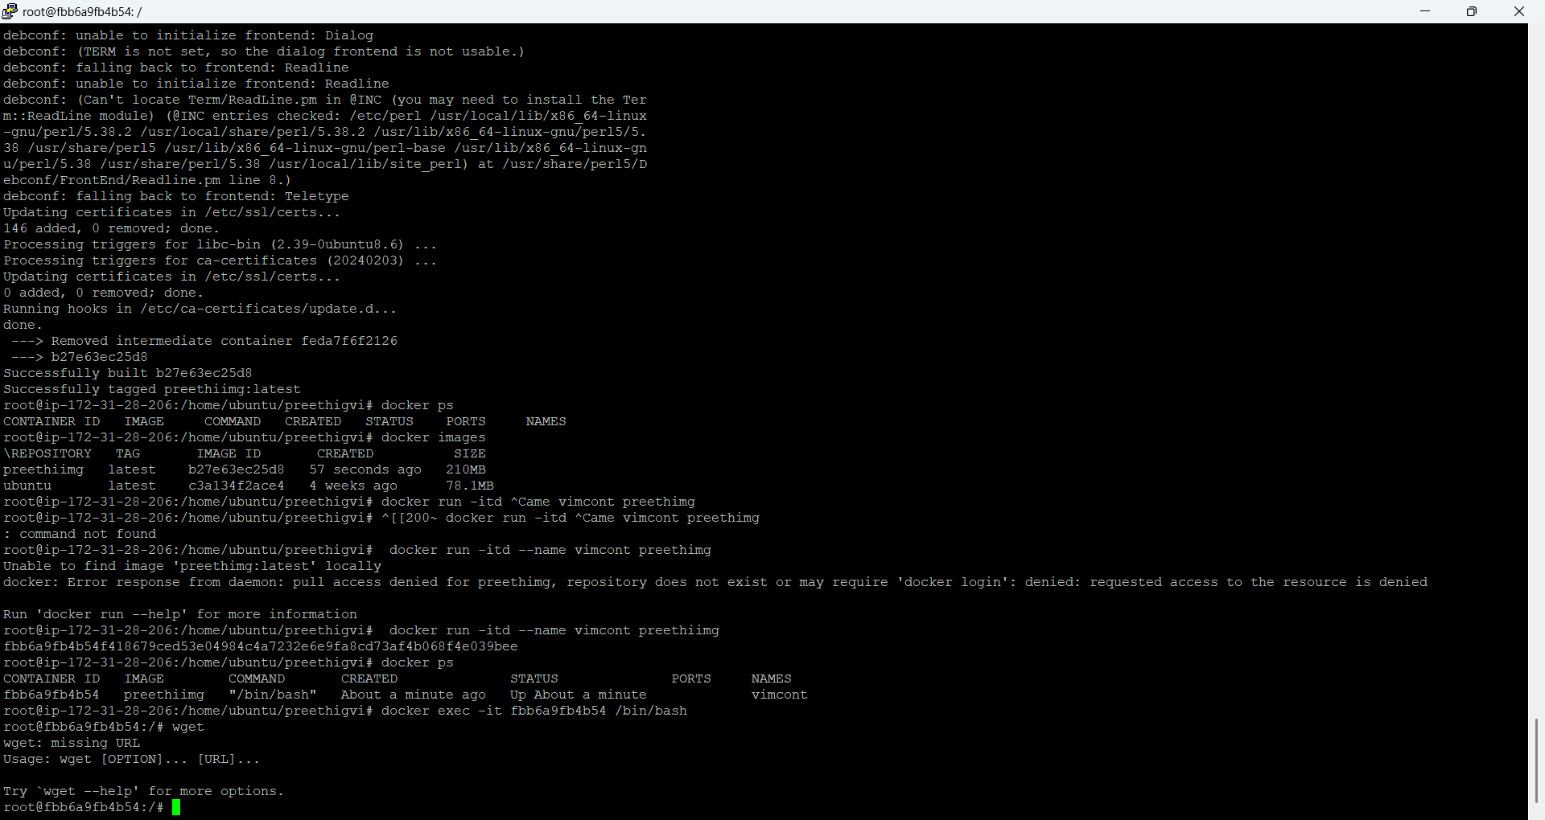

Push the docker local image to docker hub
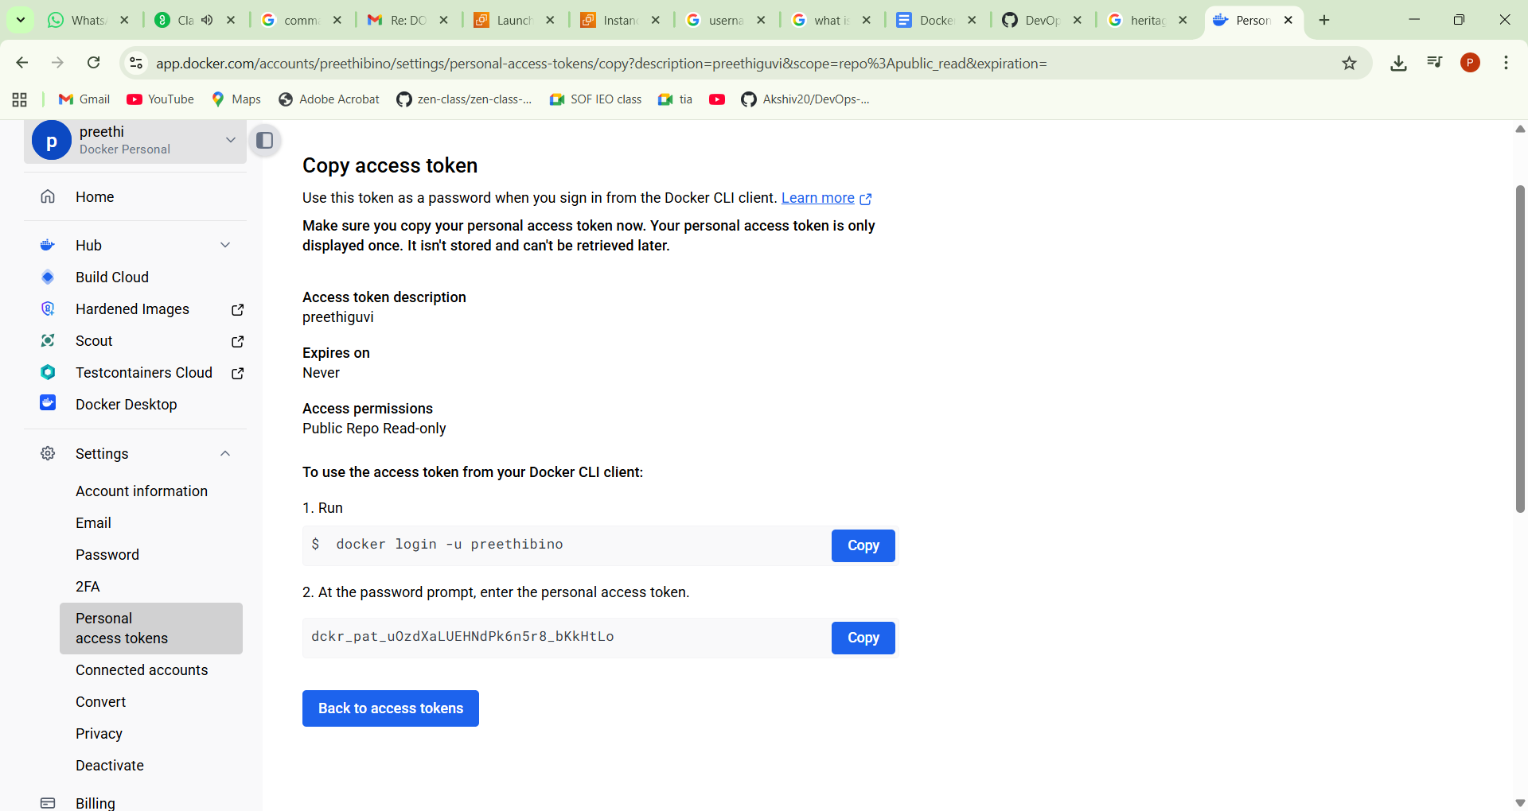
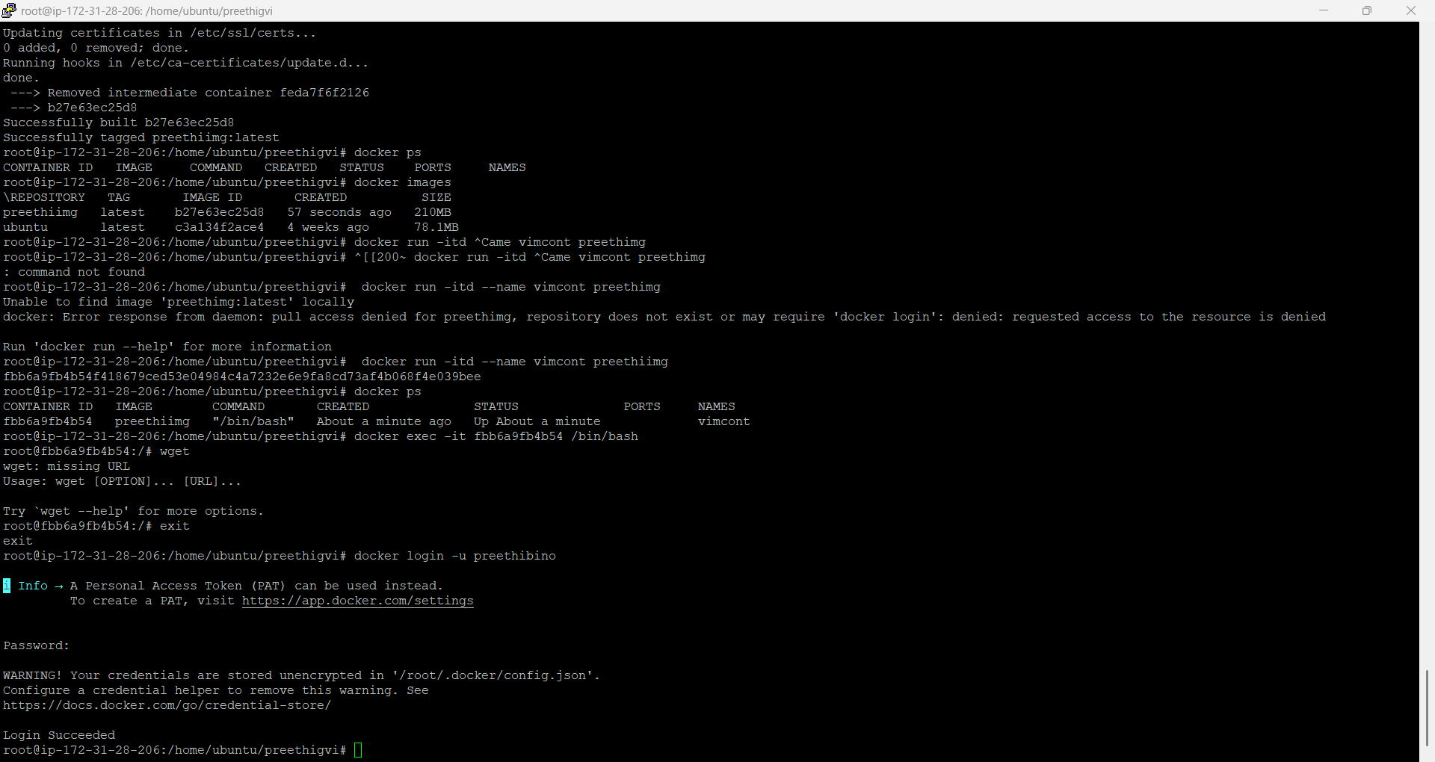
docker tag preethiimg preethibino/21nov
preethibino is the docker username – should be same. Then get pushed

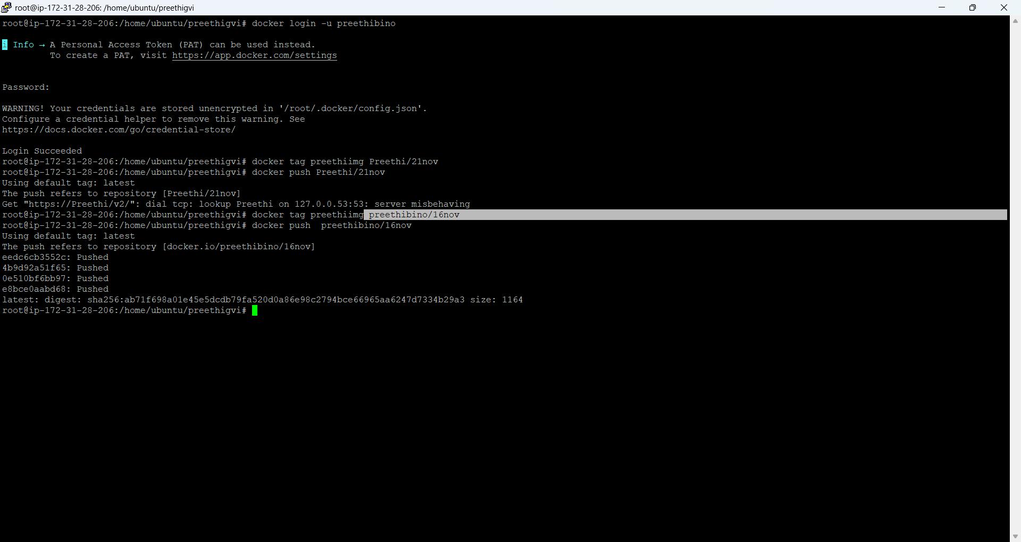

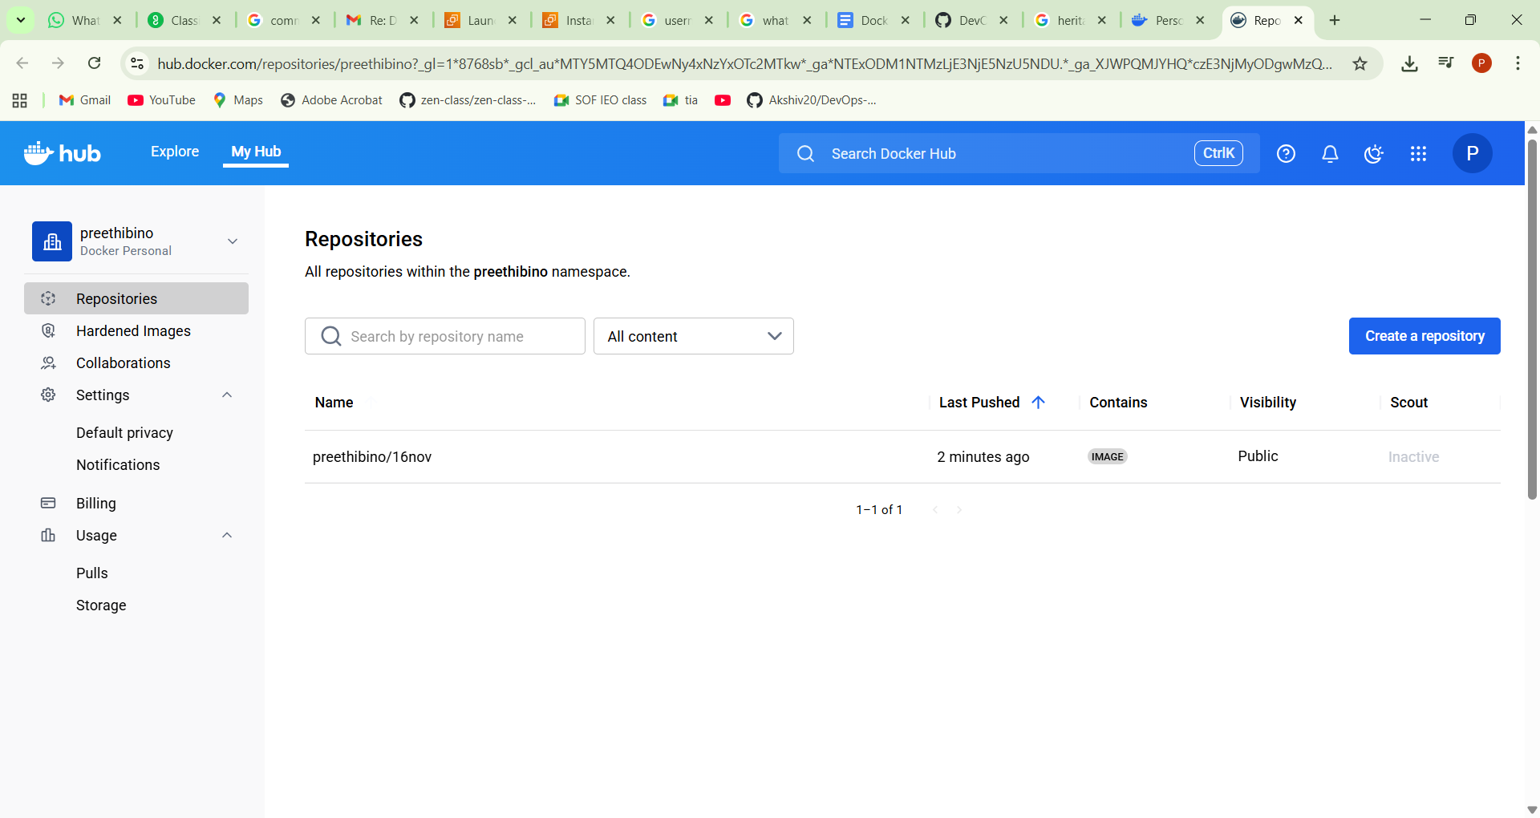

Docker compose
Follow instructions in https://docs.docker.com/compose/install/linux/ to get the docker compose installed

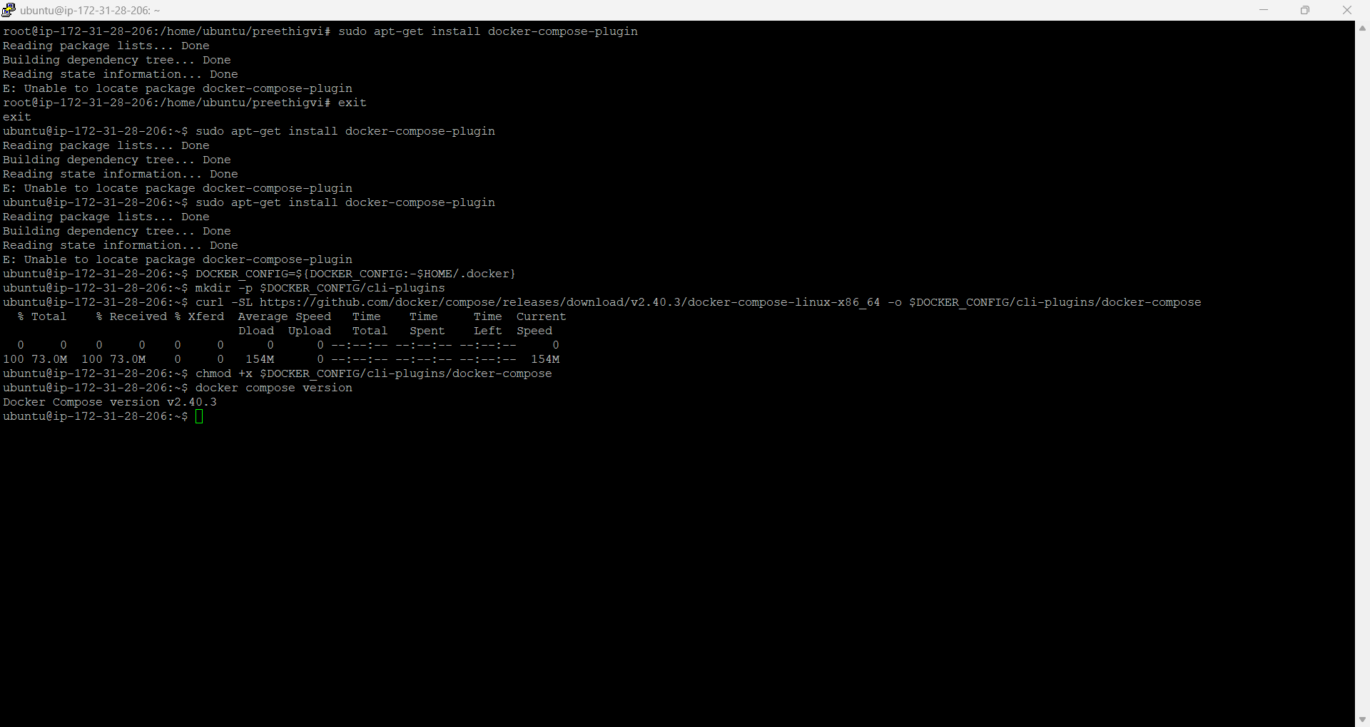

Created following files
Compose.yaml
version: '3.8'
services:
webserver:
# Use 'build: .' to tell compose to look for a Dockerfile in the current directory
build: .
container_name: my_custom_webserver
ports:
- "80:80"
2.dockerfile
# Start from a lightweight Nginx base image
FROM nginx:alpine

# Copy the local index.html file to the Nginx default directory
COPY index.html /usr/share/nginx/html/index.html

# Expose port 80 (optional, Nginx already handles this)
EXPOSE 80

# The default command to start Nginx is already in the base image (nginx -g 'daemon off;')
CMD ["nginx", "-g", "daemon off;"]
Index.html
<!DOCTYPE html>
<html>
<head>
<title>My Details</title>
</head>
<body>
<h1>About Me</h1>
<p><strong>Name</strong>preethi </p>
<p><strong>Occupation</strong>checking guvi</p>
<p><strong>Locationi</strong>chennai</p>
<p><strong>Inteersti</strong>aws</p>

</html>
~
Command to bring docker.. docker-compose up -d
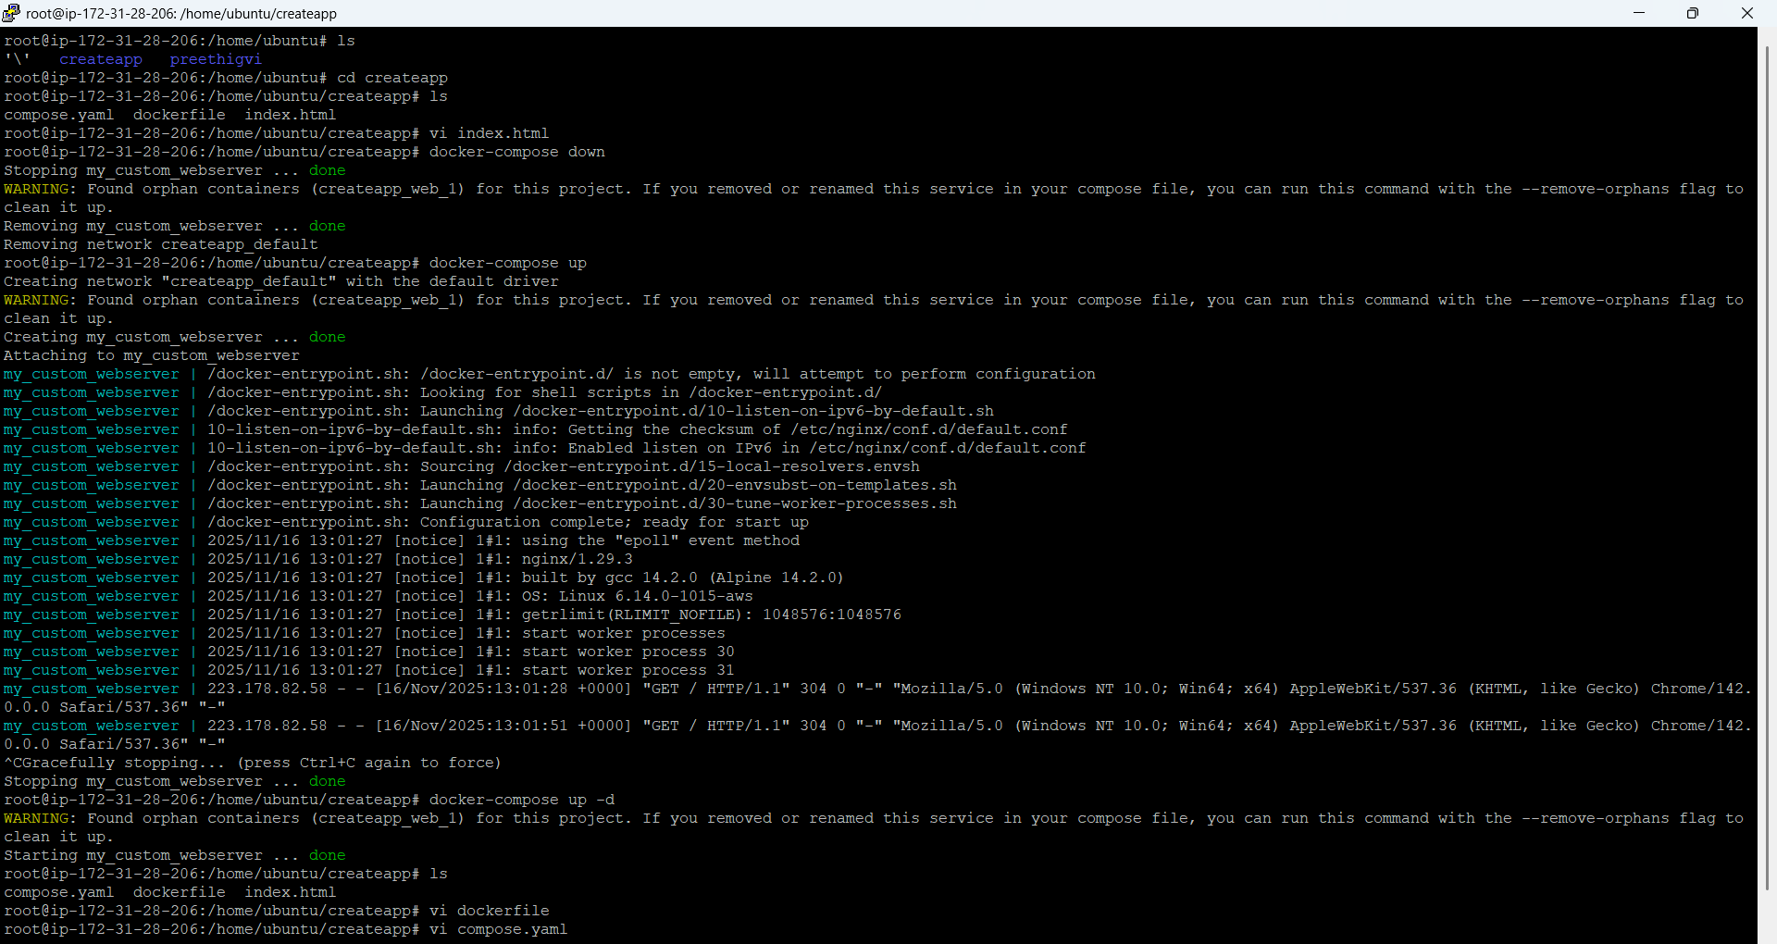

Website ran with details”
